The “Caboose” Wall Stove Manual

509 Stoves

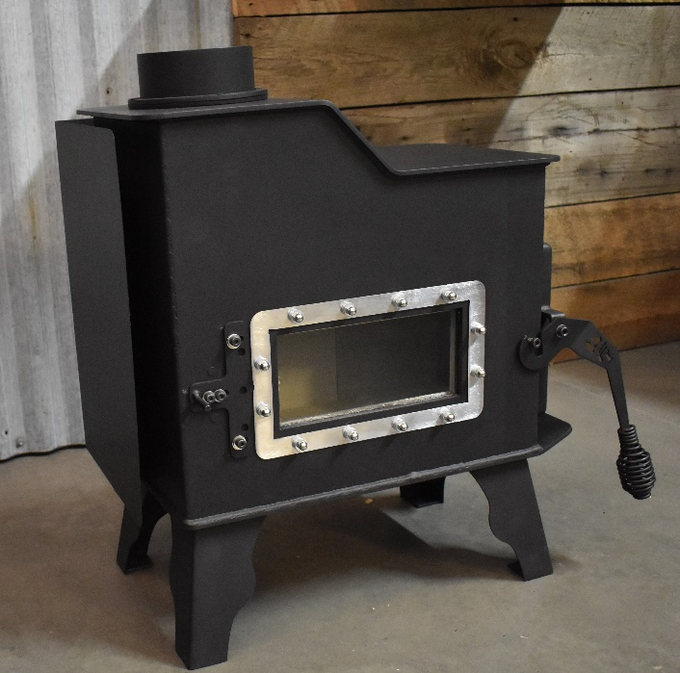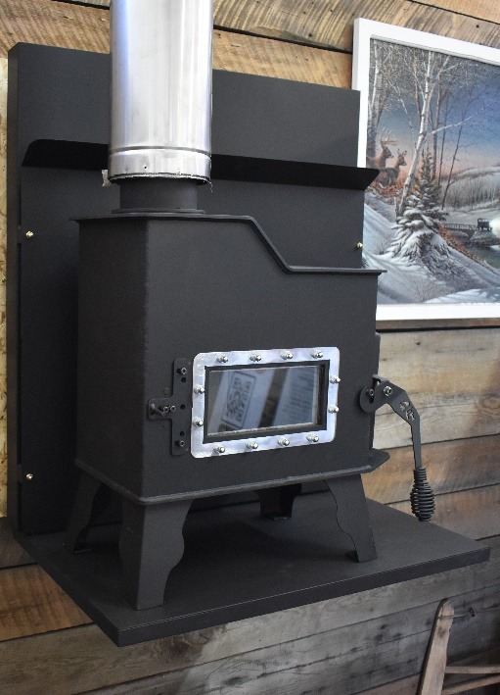
The “Caboose” Wall Stove Manual

UL 1482-11 ULC-S627-00(R2016)
08/31/2022 Project # 22-803

French Manual Available at FlameInnovation.com bottom of front page.

Manufactured by 509 Stoves
509 Fabrications, Inc.
6512 W. Seltice Way
Post Falls, ID 83854
info@509Fab.com
This stove is sold for recreational use only. Non-EPA Compliant

Proudly Made in the USA Rev. 2.0 09/2022
Disclaimer: All Wood stoves burn differently in how they are controlled, Type and BTU content of wood used, capacity of the fire box etc. Wood burning tests on this model using Birch firewood at load capacity with a moisture content of 15 to 22% produced consistent burn times of 4 to 6 hours from start to small coal bed.

CAUTION: This unit must be installed in accordance with these instructions and must comply with local building and fire codes. Failure to do so could result in a chimney or house fire. Keep children, furniture, fixtures, and all combustible materials away from any heating appliance. Refer to this owner’s manual for all clearances to combustible materials.

This stove is sold for recreational use only. Not EPA Tested for home heating except for Emergency heating

Use provided tool for cleaning glass and moving draft slides. There are no spring handles. Never move by hand unless the stove is off and cold.

SAVE THESE INSTRUCTIONS
ANY AND ALL SAFETY PRECAUTIONS MUST BE TAKEN AT ALL TIMES DURING OPERATION AND MAINTENANCE OF YOUR STOVE. Read this entire manual before you install and use your new room heater. If this heater is not properly installed, a structure fire may result. To reduce the risk of fire, follow the installation instructions. Failure to follow instructions may result in property damage, bodily injury, or even death.

CAUTION: Stove is heavy (50 to 85 lbs.) In addition, when handling any sheet metal products, be aware that there may be sharp edges or burrs. Although we make every effort to eliminate any sharp edges, please use caution when handling any metal parts. Remember to always allow the stove to completely cool down before performing any maintenance.

CAUTION: If you have any doubt concerning your ability to complete your installation in a professional-like manner after reading these instructions, you should obtain the services of an installer who is versed in all aspects as to the correct and safe installation. Do not use temporary, makeshift compromises during installation.

Precautionary Statements

509 Stoves highly recommends the use of smoke detectors and Carbon Monoxide detectors with any hearth product, including this unit. Follow all manufacturer’s instructions when using smoke or Carbon Monoxide detectors. DO NOT INSTALL THIS STOVE IN A SLEEPING ROOM

CAUTION ONCE AGAIN PLEASE READ AND FOLLOW. If you have any doubt concerning your ability to complete your installation in a professional-like manner after reading these instructions, you should obtain the services of an installer who is versed in all aspects as to the correct and safe installation. Do not use temporary, makeshift compromises during installation.

WARNING: THINGS TO REMEMBER IN CASE OF A CHIMNEY FIRE: 1. CLOSE DRAFT CONTROL 2. CALL THE FIRE DEPARTMENT
BEFORE INSTALLATION OF YOUR APPLIANCE
HOT WHILE IN OPERATION. KEEP CHILDREN, CLOTHING AND FURNITURE AWAY. CONTACT MAY CAUSE SKIN BURNS. DO NOT BURN GARBAGE OR FLAMMABLE FLUIDS.

1. Check with the building inspector’s office for compliance with local codes; a permit may be required, even though this is a recreational stove.
2. A 4” diameter flue is required for proper performance.
3. Always connect this unit to a chimney and NEVER vent to another room or inside a building.
4. DO NOT connect to any duct work to which another appliance is connected, such as a furnace.
5. DO NOT connect this unit to a chimney flue serving another appliance.
6. DO NOT USE CHEMICALS OR FLUIDS TO START THE FIRE.
7. The connector pipe and chimney should be inspected periodically and cleaned if necessary.
8. Remember the clearance distances when you place furniture or other objects within the area. DO NOT store wood, flammable liquids or other combustible materials too close to the unit.
9. Contact your local fire authority for information on how to handle a chimney fire. Have a clearly understood plan to handle a chimney fire. In the event of a chimney fire, turn air control to a closed position and CALL THE FIRE DEPARTMENT.
10. DO NOT tamper with the combustion air control beyond normal adjustment.
11. Once the required draw is obtained, operate only with door closed; open slowly when refueling.
12. Clean the stove glass before lighting the stove.
15. Visit our web site at 509Stoves.com or call us at 509-993-3767

ALWAYS PROVIDE A SOURCE OF FRESH AIR INTO THE ROOM WHERE THE UNIT IS INSTALLED. FAILURE TO DO SO MAY RESULT IN AIR STARVATION OF OTHER FUEL BURNING APPLIANCES AND THE POSSIBLE DEVELOPMENT OF HAZARDOUS CONDITIONS.

Note on Outside Air Hookup: We highly recommend fresh air for tiny spaces. This involves connecting an aluminum flex pipe (usually three inches (3”) in diameter from the air inlet pipe located on the BACK SIDE OF THE WALL BRACKET. Run flex pipe through your floor or wall. The outside end of this pipe should be covered in some manner (i.e. with a screen) to keep it clear of foreign matter. Be sure to keep it above the snowdrift line and clear of leaves and other debris. DO NOT USE A SCREEN SO FINE IT INHIBITS AIR FLOW.

FLUE SYSTEM
The Caboose Stove is designed for use with a 4” Flue System either in single wall (Minimum 24ga. Metal or Stainless Steel) or Class “A” 4” Pipe for 2” Clearance to combustibles around the pipe only, not the stove at any time.
(The black or non-painted single wall connector pipe should be at least 24ga. steel and a minimum of 12 inches (12.0”) from a combustible wall and eighteen inches (18.0”) from ceiling before transitioning to the Class A pipe to go through the wall or ceiling.
It is permissible to use single wall pipe and Class A pipe both if you follow your counties rules and regulations with no single wall pipe penetrating any surface without 18” Clearance to combustibles around it. It is recommended in this situation to convert to Class A pipe at the ceiling box transition.
It is not permissible to connect this unit to a chimney that is servicing another unit.

Flue Size-The proper flue size is determined by measuring the inside diameter of the flue collar on the unit. This stove is equipped with a four-inch (4”) TOP EXHAUST FLUE COLLAR. Therefore, the connector pipe should be four inches (4”) and never less in diameter than the collar on the stove. Your unit may require an adapter which will reduce the 4” connector pipe by 1/8”. This is necessary to accommodate pipe variation from different manufacturers and maintain a good seal. All Joints should be sealed and checked for leaks.

ALL CHIMNEY PIPES AFTER BURNING AND INSTALLING SHOULD BE CLEANED AND INSPECTED ON A REGULAR BASIS DEPENDING ON HOW MUCH YOU ARE BURNING.

It is the consumer’s responsibility to ensure the chimney system is safe and in good operating condition. The manufacturer will not be held responsible for an accident attributed to a unit connected to a faulty chimney system. This stove is considered a recreational stove and carries no warranty except for shipping damage, which must be reported with 10 days of receiving shipment to ensure replacement or repair from a warranty claim through the shipping company.

*IMPROPER INSTALLATION: The manufacturer will not be held responsible for damage caused by the malfunction of a stove due to improper installation, CHIMNEY FIRES OR OVER-FIRING THE STOVE. Do not use makeshift methods or material which may compromise the installation. 509 STOVES will not be liable for consequential or indirect damages to property or persons resulting from the use of this product. consult a professional installer if you have any questions.

FLOOR AND WALL PROTECTION

STOVE DOES NOT HAVE BUILT IN HEAT SHIELDS. IF INSTALLING “FREE STANDING” A HEAT SHIELD IS NECESSARY AND MUST BE INSTALLED ON THE STOVE.
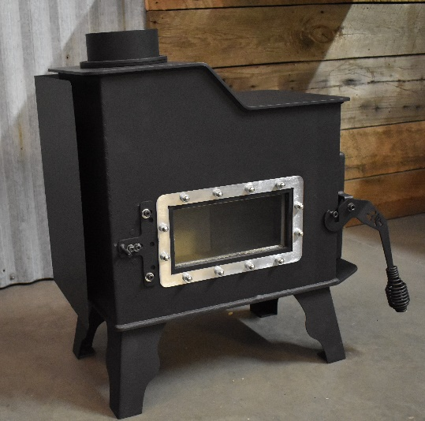

Note: Heat Shield installed at factory when
The stove is ordered as a Free-Standing
Installation.
- You will not need any floor protection if your floor is constructed of a non-combustible material such as brick or concrete. If your floor is constructed with a combustible material such as hardwood, carpet or linoleum, you must place protection between the stove and the combustible material. There are many floor and wall board manufacturers. The type of board you choose should be U.L. rated and listed Fiber Board. After examining the area you plan to place your stove and determining it requires a board, the next step is to select the proper size. The stove you choose will determine the size board that is required. The approved protector board should be large enough to provide a minimum of eight inches (8”) behind the unit, eight inches (8”) on either side and sixteen inches (16”) in the front where the door is located. This stove requires a minimum of 42.0” D x 36.25” W floor protection.
- Installation on a Concrete Floor An appliance mounted on a concrete floor does not require floor protection. Carpeting and any other combustible material must not cover the Floor Protector. If a combustible surface is applied to the concrete floor, a clearance must be maintained equivalent to the area reserved for the floor protector. Floor Protection Footprint Minimum Size 42.0” x 36.25”

Installation on a Combustible Floor If the appliance is to be installed on a combustible floor or a combustible floor covering, it must be installed on a 1” thick non-combustible millboard floor protector or a durable equivalent, with a “R” factor of no less than “2.” The pad must be installed beneath the unit, extending 16” (U.S.) (18” Canada) on the side equipped with the door, and 8” on all other sides. The pad must cover any horizontal chimney connector runs and extend 2” beyond each side.

Wall Protection for “Free Standing” Installation (Cont’d)
In some areas local codes may require thirty-six inches (36”) from a combustible, therefore it is very important that you check with local officials. If you need to place your unit closer to a combustible wall, some protection will be necessary. If an approved wall board is used this will reduce your clearance by two thirds (2/3); however, a one-inch (1”) air space has to be between the board and the wall. If you have a ceiling flue hook-up, you will need protection from the floor to the ceiling if you do not meet the normal clearances. If you have a wall flue hook up, you will need wall protection at least twelve inches (12”) above the wall thimble.

Free Standing Heat Shield Installation
The Free-Standing heat shield must be installed if you are not using the wall kit and the stove is placed on a fire proof floor or hearth pad. Remove the corresponding nuts on the rear legs of the stove and slide the heat shield in and put the legs back on. If the stove must be turned on its side, make sure to check everything for placement inside the stove before starting your first fire. Bricks will shift and must be securely placed back in the stove.

NOTE: THIS UNIT IS UL TESTED. INSTALL TAKING ALL PRECAUTIONS AND TEST YOUR CLEARANCE TO COMBUSTIBLES AFTER INSTALL TO MAKE SURE SURFACES AROUND THE STOVE DO NOT GET HOT!!!
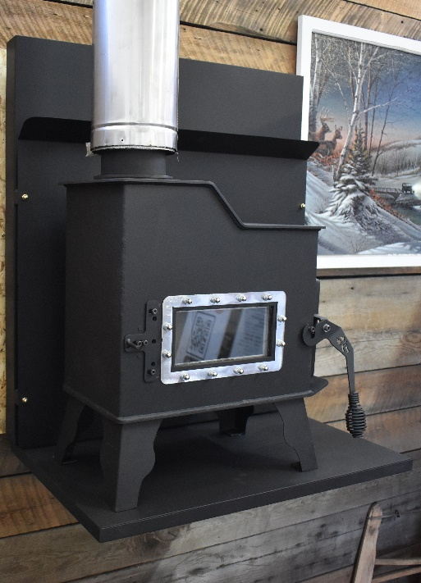
Wall Mount Install Shown.

Wall Bracket must be mounted securely to the wall stud using 3 Lag Bolts in 7/16 x 3” in Length. Remove front heat shield cover to expose frame mounting holes. When wall bracket is installed, mount the stove to the shelf by bolting the feet to the bracket using the nuts and bolts provided in the kit. Find you chimney exit point and adjust the wall shield frame as needed for vertical exhaust and tighten the 2 set bolts on top to secure the frame on the mount. Install the heat shield using the acorn nuts provided. No other wall protection behind the frame is required.
NOTE: you must leave at least 16” clearance to a wall on the door end and inspect that wall for heat after burning the stove and install a wall shield on the side wall if needed. The other end of the stove needs 16” to a side wall. Install a heat shield there if necessary.

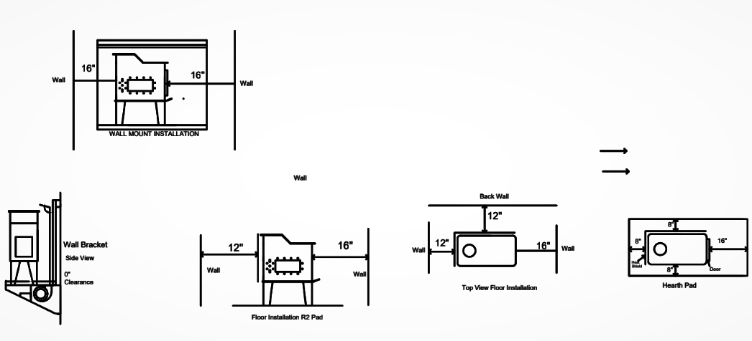

INSTALLATION

THIS ROOM HEATER MUST BE CONNECTED TO:
- A chimney complying with the requirements for Type-HT Chimneys in the Standard for Chimneys, Factory-Built, Residential Type and Building Heating Appliance, UL 103 or
- A code-approved masonry chimney with a flue liner.
Canada: Where passage through a wall or partition

IT IS RECOMMENDED TO USE 4” CLASS A INSULATED STOVE PIPE. OPTIONAL 2 FT SECTION OF SINGLE WALL PIPE CAN BE USED DIRECTLY OFF THE STOVE AS LONG AS THE WALL IS PROTECTED AND CORRECT CLEARANCES CAN BE MAINTAINED.
1. Remove all parts from inside the stove body.
2. Select the proper location for the stove. These appliances must not be installed any closer than the minimum clearance to combustible materials shown.
3. The stove must be installed on a non-combustible surface
4. If non-combustible materials have been installed on the walls, obtain the minimum clearances from either the manufacturer of these materials or the local building inspector’s office.
5. Install the first section of stovepipe INSIDE the flue collar on the top of the stove, between the stove and the chimney and seal with high temp 2000-degree stove pipe sealant utilizing the stove pipe adapter that will be your connection to the first piece of
Installation Cont’d

Class A insulated pipe. If using a 2 ft. section of single wall pipe first off the stove, slide the crimped end into the stove collar and seal and screw the pipe through the holes in the stove collar. The stove pipe adapter to the Class A Insulated pipe must be used at the top end of the single wall pipe, then screwed and sealed inside the section of pipe to adapt to the insulated pipe.
6. DO NOT use a grate to elevate the fire inside the firebox Build fire directly on hearth.
7. A clearance of 12 inches (12”) for 4” single wall pipe between the single wall stove pipe and combustible materials is required. A clearance of 2” can be maintained when using the UL approved Class A Insulated pipe. Check with authorities having jurisdiction in your area with any questions and to verify clearances.
8. All pipe sections must be connected with the male (crimped) end toward the stove.
9. Fasten the stove pipe to the flue collar using three sheet metal screws. Do the same at each additional joint to make the entire installation rigid.
10. Maintain the required diameter flue for the entire installation according to local rules and regulations.
11. It is recommended that no more than two 90-degree bends be used in the stovepipe installation. More than two 90-degree bends may decrease the amount of draw, and possibly cause smoke spillage. (45 Degree Elbows are preferred)
12. An Inline damper is not required in this installation. If there is a damper built into the chimney pipe remove the damper plate in the chimney or secure it in the OPEN position. FAILURE TO FOLLOW THE MINIMUM CLEARANCE REQUIREMENTS MAY RESULT IN AN UNSAFE INSTALLATION.
13. Single wall flue pipe assemblies for wall tents, camping, etc. must not exceed 10 feet (10’) in overall length and pass through a wall or ceiling without the proper clearances to combustibles (most areas 18”) and proper metal box separators to surround the pipe and protect the wall and ceiling. Some cases at higher elevations above 5000 ft. may need additional Pipe sections.
14. ALWAYS Check for Leaks

An R-2 Hearth Pad is Required for Free-Standing Installation
Type 2 – Traditional Hearth Pads
Fully non-combustible, with an R-value of 2.24 or 1.592 (R-value information), it provides protection well above the minimum requirements for Type 2 hearth pads (minimum requirement of R-value=1.0).

Your hearth pad is the layer of material that sits between your stove or fireplace and the floor or subfloor under it. Often made of natural stone tile, ceramic tile, thin set cement board and other building materials, the hearth pad protects the subfloor from the heat of the fire above it. Its R-value, or thermal resistance, tells you how well it insulates the subfloor. To find the R-value, you need to know what materials the hearth pad is made of and their relative R-values, K-values or C-values. These other two values measure thermal conductivity.
Look at the edge of the hearth pad, so you can see a cross-section of all its materials. If you have already installed the hearth pad, you might have to remove a decorative tile bevel or some other sort of edging to see the cross-section.
Measure the height in inches of each material used in the hearth pad. For example, if the hearth pad has a layer of cement board on the bottom, a layer of thin set in the middle and a layer of ceramic or stone tile on top, measure the height of each layer.
Consult an R-value chart to determine the R-value of each layer. Hearth manufacturers, insulation manufacturers and utility companies may have these charts on their websites or in their stores or offices.
Add the R-values of all the layers in the hearth pad to find the hearth pad's total R-value.
Measure the thickness of any layers of the hearth pad for which you know the K-value. You don't need to measure the layers for which you know the C-value.
Divide 1 by the K-value of the layer. Multiply the result by the thickness of the layer. This gives you its R-value. For example, if you have a 1/2-inch layer of a material with a K-value of 0.3, divide 1 by 0.3 to get 3.333, then multiply that by 0.5 to get an R-value of 1.667.
Divide 1 by the C-value of a layer. This gives you the R-value. For example, if you have a layer with a C-value of 1.15, divide 1 by 1.15 to get an R-value of 0.87.
Repeat these calculations for any remaining layers. Add the R-values together to get the total R-value for the hearth pad.

MASONRY CHIMNEY
Ensure that a masonry chimney meets the minimum standards of the National Fire Protection
Association (NFPA) by having it inspected by a professional. Make sure there are no cracks, loose mortar or other signs of deterioration and blockage. Have the chimney cleaned before the stove is installed and operated. When connecting the stove through a combustible wall to a masonry chimney, special methods are needed. Refer to Combustible Wall Chimney Connector Pass-Throughs.

MASONRY FIREPLACE
There are listed kits available to connect a stove to a masonry fi replace. The kit is an adapter that is installed at the location of the fi replace damper. The existing damper may have to be removed to allow installation.

METHOD A.
12” (304.8 mm) Clearance to Combustible Wall Member: Using a
minimum thickness 3.5” (89 mm) brick and a 5/8” (15.9 mm) minimum
wall thickness clay liner, construct a wall pass-through. The clay
liner must conform to ASTM C315 (Standard Specification for Clay
Fire Linings) or its equivalent. Keep a minimum of 12” (304.8 mm)
of brick masonry between the clay liner and wall combustibles. The
clay liner shall run from the brick masonry outer surface to the inner
surface of the chimney flue liner but not past the inner surface. Firmly
grout or cement the clay liner in place to the chimney flue liner.
METHOD B.
9” (228.6 mm) Clearance to Combustible Wall Member: Using a 6”
(152.4 mm) inside diameter, listed, factory-built Solid-Pak chimney
section with insulation of 1” (25.4 mm) or more, build a wall passthrough
with a minimum 9” (228.6 mm) air space between the outer
wall of the chimney length and wall combustibles. Use sheet metal
supports fastened securely to wall surfaces on all sides, to maintain
the 9” (228.6 mm) air space. When fastening supports to chimney
length, do not penetrate the chimney liner (the inside wall of the Solid-
Pak chimney). The inner end of the Solid-Pak chimney section shall
be flush with the inside of the masonry chimney flue, and sealed with
a non-water-soluble refractory cement. Use this cement to also seal
to the brick masonry penetration.
METHOD C.
6” (152.4 mm) Clearance to Combustible Wall Member: Starting with
a minimum 24 gage (.024” [.61 mm]) 6” (152.4 mm) metal chimney
connector, and a minimum 24 gage ventilated wall thimble which has
two air channels of 1” (25.4 mm) each, construct a wall pass-through.
There shall be a minimum 6” (152.4) mm separation area containing
fiberglass insulation, from the outer surface of the wall thimble to wall
combustibles. Support the wall thimble, and cover its opening with
a 24- gage minimum sheet metal support. Maintain the 6” (152.4
mm) space. There should also be a support sized to fi t and hold the
metal chimney connector. See that the supports are fastened securely
to wall surfaces on all sides. Make sure fasteners used to secure the
metal chimney connector do not penetrate chimney flue liner.
METHOD D.
2” (50.8 mm) Clearance to Combustible Wall Member: Start with a
solid-pack listed factory-built chimney section at least 12” (304 mm)
long, with insulation of 1” (25.4 mm) or more, and an inside diameter
of 8” (2 inches [51 mm] larger than the 6” [152.4 mm] chimney connector).
Use this as a pass-through for a minimum 24-gage single
wall steel chimney connector. Keep solid-pack section concentric with
and spaced 1” (25.4 mm) off the chimney connector by way of sheet
metal support plates at both ends of chimney section. Cover opening
with and support chimney section on both sides with 24 ga
minimum sheet metal supports. See that the supports are fastened
securely to wall surfaces on all sides. Make sure fasteners used to secure
chimney flue liner.
NOTES:
1. Connectors to a masonry chimney, excepting method B, shall extend in one continuous section through the wall pass-through
system and the chimney wall, to but not past the inner flue liner face.
- A chimney connector shall not pass through an attic or roof space, closet or similar concealed space, or a floor, or ceiling.
- THE CABOOSE DOES NOT HAVE A REAR EXHAUST OUTLET, THEREFOR DO NOT INSTALL IN OR UP A BUILT IN FIREPLACE / HEARTH FIREPLACE. DO NOT MOUNT THE STOVE IN FRONT OF A BUILT IN FIREPLACE AND RUN THE CHIMNEY UP THROUGH THE OPENING AT GROUND LEVEL. ONLY INSTALL AS DESCRIBED ABOVE BY A THROUGH WALL PENETRATION TO THE CHIMNEY LINER.
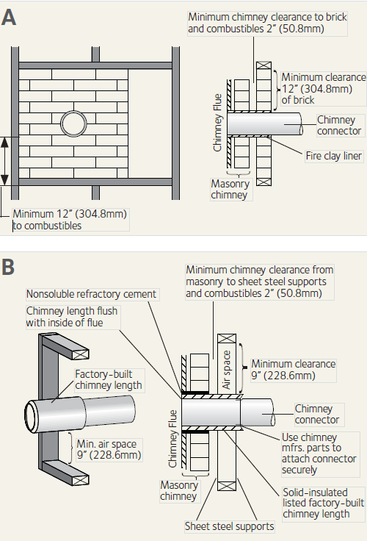
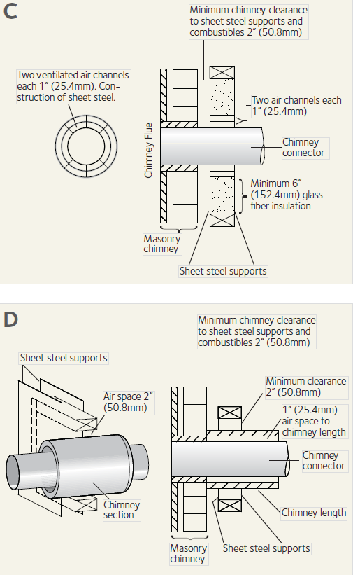
Class A Pipe from 18” before ceiling or wall penetration above 2 ft single wall pipe off stove. Continue use of Class A pipe through ceiling
and outside. Wall Exit use 45 degree elbow inside, Class A through wall and 45 degree elbow outside and class A Vertical to Chimney Cap.
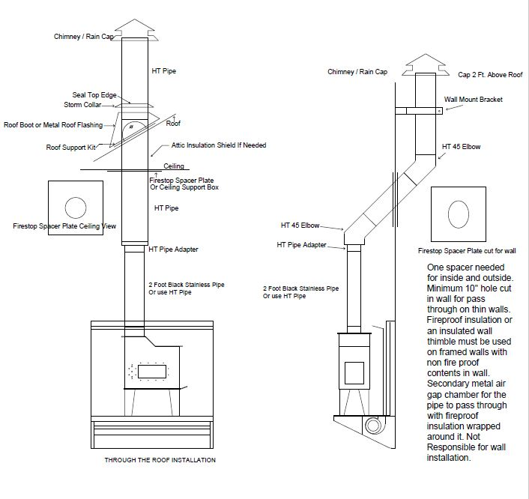

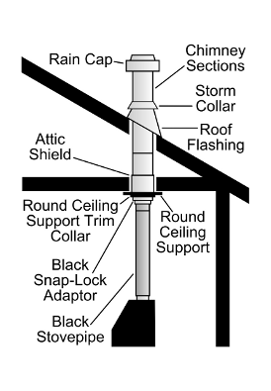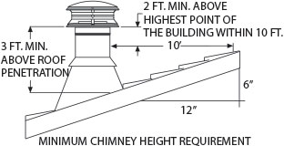

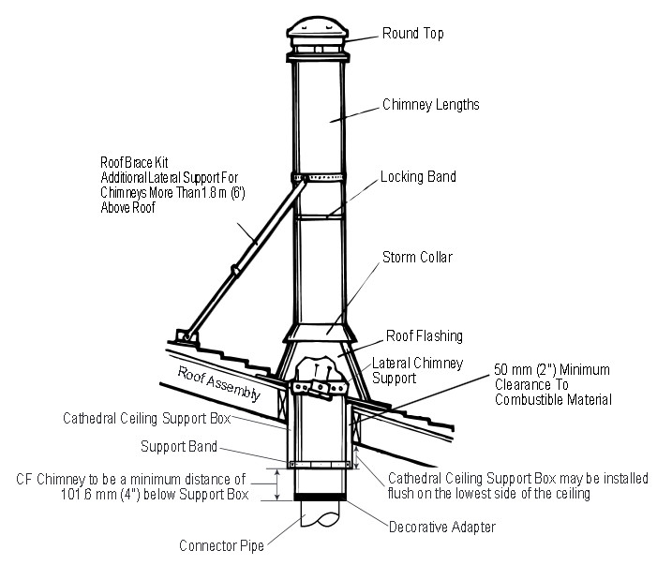
Chimney at ceiling
Note: You must Maintain 18” From Ceiling with single wall Pipe and minimum 12” From walls with 1” Air Gap behind Non-Flammable wall boards.

Outside Air Connection
The stove can accept a 3-inch aluminum flex tube for outside air if using the wall bracket kit. Make sure when connecting the fresh air tube to the outside that you cover the end with a screen of some sort, but not a screen that would restrict air in-flow. Utilize a screen with wider openings. If installing on the floor hearth pad without the wall bracket with built in air, it is recommended to have a fresh air intake close (within 18”) to the stove.

BUILDING A FIRE
At least 3 small fires should be lit in the stove to cure the paint and the bricks inside. Do not build a full fire box fire until you have performed these steps.
Open the door draft control to approximately ½ open. Close the draft control on the air wash on the front of the stove to the left of the stove glass window, and leave closed until your fire is well underway and in control. After seasoning the stove, start with 2 small to medium sized pieces inside the firebox. Place smaller pieces on top of the medium pieces building to very small at the top of the pile of wood with small light-able kindling strips of wood. DO NOT OVER FILL THE FIREBOX ON THE INITIAL LOAD SO YOU CAN BUILD A COAL BED. Start your fire by igniting the kindling from the top and close the door. Always make sure to close and positively latch the door immediately after starting the fire. A couple of times lighting the stove, you will figure out what works best for you. Different lengths of chimney, draft control on the door of the stove and types of chimneys used for configuration, elevation, and temperature play roles in how the fire will burn. Find your best spots on the draft control as you test your stove and learn how it operates to burn it clean and efficient.
FIRST FIRE
Remember to ventilate well. Allow the stove to cure before burning for long periods of time at high temperatures. Flat spots on the painted surface are normal. Shiny spots on the painted surface (before burning) are normal. At least 3 small fires should be lit in the stove to cure the paint and the bricks inside. Do not build a full fire box fire until you have performed these steps. See Draft Control Operation in next section to set your stove to light and burn.

STOVE LEGS
Stove legs are removable. DO NOT INSTALL OR BURN STOVE WITHOUT LEGS ATTACHED. Free standing install requires the back 2 legs to be removed to install the heat shield. Replace and tighten ¼-20 KEPS nuts after the heat shield is installed.
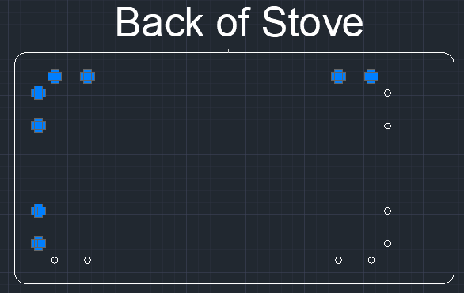

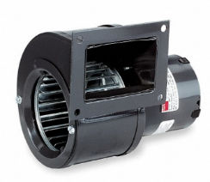OPTIONAL BLOWER FOR WALL MOUNT BRACKET ONLY
An optional blower can be added underneath the wall mount bracket shelf. Use the following information and specs on the type of blower motor to install for correct fitment.
Use ¼-20 x ¾” Bolts with lock washers and nuts to install. Unplug before installing.
A SUBSTITUTE BLOWER MAY BE USED WITH EXACT SAME SPECIFICATIONS FOR SAFETY
Dayton Blower: OEM Blower: Rectangular, With Flange, 3 13/16 in Blower Wheel Dia., Shaded Pole Motor, 115V AC.
- Item #6FHX8
- Mfr. Model #70213469X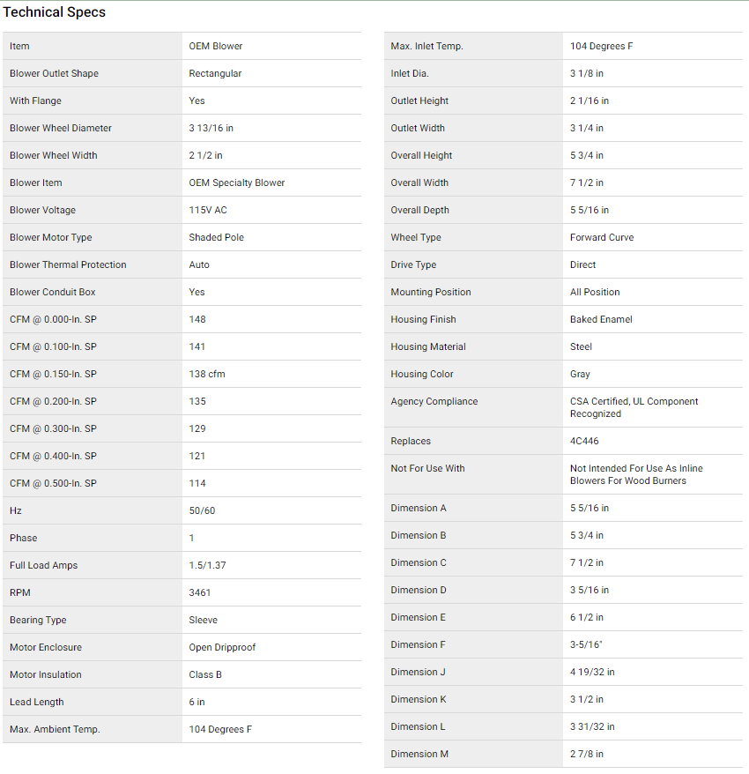
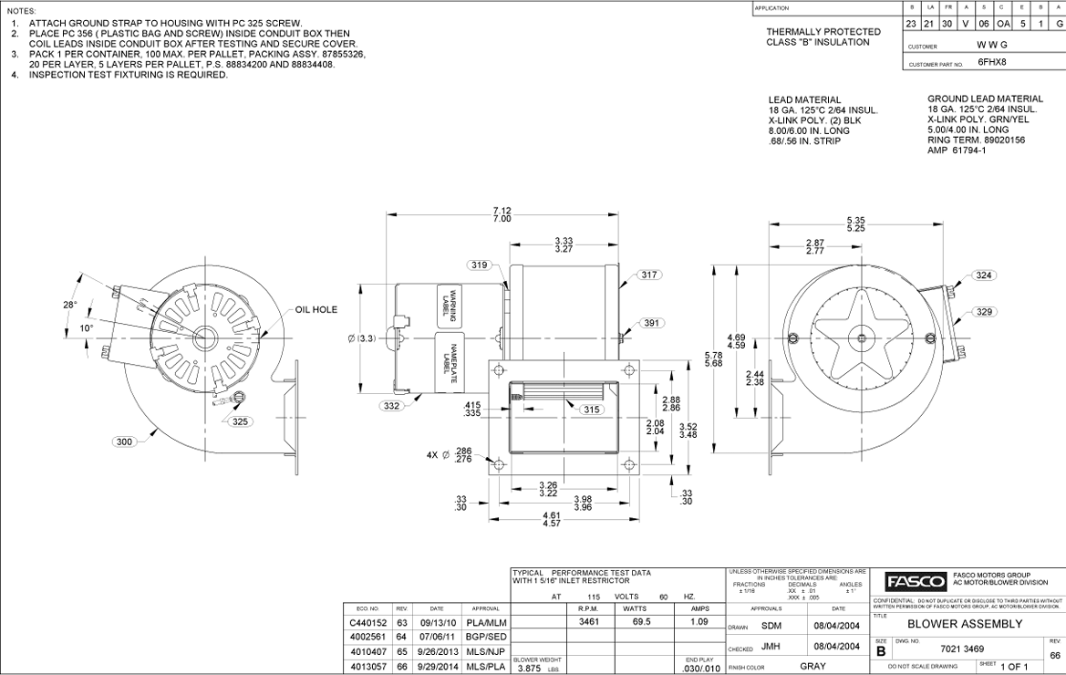
DRAFT / AIR CONTROLS
The draft control on the door must be open to operate the stove. Use the tool provided with the stove that cleans the glass with a built-in removable razor blade and hole on the side of the tool to slide the draft control on the door, especially when the stove is in operation, as the rod that controls the draft placement gets extremely hot. Move your air wash control rod with the tool provided as well. WHEN STARTING A FIRE, CLOSE THE AIR WASH DRAFT SLIDE UNTIL THE STOVE REACHES TEMPERATURE OR APPROXIMATELY 20 MINUTES AFTER LIGHTING THE FIRE.

NEVER COMPLETELY CLOSE THE DRAFT CONTROL ON THE DOOR.

REFER TO “BUILDING A FIRE” AS YOU ARE READING THIS SECTION

1.Do not use a grate or elevate the fire inside the firebox.
2. Build the wood fire directly on the bricks inside the stove. The brick lined firebox should not be altered or overfilled. 2 pieces of wood must be lined side by side inside the stove and not too tightly in order to burn correctly. Build your kindling with smaller sizes as you build up. Do not overfill the firebox on the initial fire of the day. Build your coal bed before filling your fire box with wood. It is best to use split wood, not round logs that are not split.

When the stove is used for the first time, solvents in the paint will smoke off as the stove “cures.”

WOOD/FUEL – This heater is designed to burn Cordwood. Natural SAWDUST LOGS without additives can be burned in the stove ONLY ONE AT A TIME. Higher efficiency and lower emissions generally result when burning NATURAL SAWDUST LOGS but these logs burn at a much higher temperature AND CAUTION MUST BE TAKEN.
Use only dry, seasoned wood. Green wood, besides burning at only 60 percent of the fuel value of dry wood, deposits creosote on the inside of the stove and along the chimney. This can cause extreme danger of chimney fire.
To be called “seasoned,” wood must be dried for a year. Regardless of whether the wood is green or seasoned, it should be stored in a ventilated, sheltered area to allow proper drying during the year. Wood should be stored beyond recommended clearances from combustibles around heaters and flame.

DO NOT BURN: Treated Wood, Garbage, Solvents, Trash, Cardboard, Colored Paper or Coal.

NEVER USE GASOLINE, GASOLINE-TYPE LANTERN FUEL, KEROSENE, CHARCOAL LIGHTER FLUID, OR SIMILAR LIQUIDS TO START OR ‘FRESHEN UP’ A FIRE IN THIS HEATER. KEEP ALL SUCH LIQUIDS WELL AWAY FROM THE HEATER WHILE IT IS IN USE.

NEVER USE LOGS THAT HAVE ADDITIVES IN THEM LIKE WAX, OILS, OR OTHER BINDING AGENTS. USE OF THESE TYPES OF LOGS CAN CAUSE A FIRE THAT IS OUT OF CONTROL VERY QUICKLY DUE TO THE ADDITIVES.

CLEAN AND INSPECT YOUR CHIMNEY REGULARILY AND WATCH OUTSIDE FREQUENTLY TO LOOK FOR SMOKE TO INSURE CORRECT DRAFT PLACEMENT FOR EFFECTIVE CLEAN EFFICIENT BURNING.

ALWAYS STORE YOUR WOOD IN A WELL-VENTILATED AREA AWAY FROM DIRECT MOISTURE.

GLASS CARE
The following use and safety tips should be observed:
1. Inspect the glass regularly for cracks or breaks. Surface scratches are acceptable and normal, but if this glass becomes cracked in any area, the unit should be shut down and the window replaced with high-temperature Neo-Ceram glass. (4.25” x 8.75”)
2. Do not slam the door or otherwise impact the glass on the front of the stove trying to force wood into the stove. When closing doors, make sure that foreign objects do not protrude and impact the glass.
3. Do not clean the glass with materials which may scratch (or otherwise damage) the glass. Scratches on the glass can develop into cracks or breaks.
4. Never attempt to clean the glass while the unit is hot. If the deposit is not very heavy, normal glass cleaners are adequate with a plain, non-abrasive scouring pad. Heavier deposits may be removed with the use of a razor blade scraper.
5. NEVER put substances that can ignite explosively inside the unit, since even small explosions in confined areas can blow out the glass.
6. Inspect the glass seal periodically to ensure proper seal. If the gaskets become frayed or worn, replace immediately. Contact your dealer or Customer Service at) 509-993-3767 for approved replacement parts.

Glass / Door Gasket Replacement
After extensive use, the sealing material which provides glass and door seal may need to be replaced if it does not sustain its resilience. Inspect the glass and door seal periodically to ensure proper seal. If the gaskets become frayed or worn, replace immediately.
The following steps should be followed for replacement of the glass or door gasket:
1. Ensure that the appliance is not in operation and is thoroughly cooled.
2. Remove the screws and glass clip Brackets.
3. Lift glass out from glass clips.
4. Remove the old gasket and clean the glass.
5. Replace the new gasket, starting at the bottom of the glass and working along the edges. Be sure to center the gasket channel on the glass.
6. Trim the gasket to length and butt the ends together.
7. Replace the glass in the front, being sure not to over-tighten the nuts, this will break the glass.
REPLACE GLASS ONLY WITH HIGH-TEMPERATURE NEO-CERAM OF THE PROPER SIZE AND THICKNESS. 3/16” x 4.25” X 8.75” You may order parts and options on our web site: 509Stoves.com or by calling (509) 993-3767

Door Gasket
The door gasket is ¾” Rope Gasket. You will have to dig the gasket out of the channel and then clean all the old gasket cement out of the channel being careful not to bend the rope channels. Use only ¾” Fire Rope to replace the door gasket. You can find it on our website as well. Use high Temp Stove Gasket Sealer on all 3 sides of the channels to secure rope in place. Place a weight, like a big book over the gasket over-night and then re-install door. Note: A clean surface is crucial to your new gasket sealing properly. DO NOT Try and re-seal over old gasketing Cement.

BRICK CARE AND LAYOUT

Inspect you bricks each time you start a fire for correct placement, checking for broken or dislodged bricks. If broken or dislodged bricks are found, they need to be replaced in position or replaced entirely if damaged.

CREOSOTE
When Sawdust Logs or wood is burned slowly, it produces tar and other organic vapors. These combine with moisture to form creosote. Creosote vapors condense in the relatively cool chimney flue of a slow-burning fire – as a result, creosote residue accumulates on the lining of the flue. If ignited, this creosote makes an extremely hot fire. The chimney should be inspected on a regular basis during the heating season, to determine if a creosote build-up has accumulated. If it has, the creosote should be removed to reduce the risk of chimney fire.
WAYS TO PREVENT AND KEEP UNIT FREE OF CREOSOTE
1. Burn with the air control fully open for several minutes at numerous intervals throughout each day during the heating season, being careful not to over-fire the unit. This should remove the slight film of creosote that accumulates during low burn periods.
2. Burn the stove with the draft control fully open for approximately 20 minutes every time you apply fresh wood. This allows fuel in the stove to achieve the charcoal stage faster and burns the vapors which might otherwise be deposited within the system. Do not over fire the stove
3. IF YOU CHOOSE TO BURN DRY MANUFACTURED LOGS, BURN ONLY ONE AT A TIME.
4. Avoid burning wet logs or green and wet wood. Seasoned wood is wood that has been dried for at least one year.
5. A small, hot fire is preferable to a large, smoldering fire that can deposit creosote within the system.
6. Establish a routine for fuel, burning and firing technique. Check daily for creosote build-up until experience shows you how often you need to clean to be safe. Keep in mind that the hotter the fire, the less creosote is deposited, and weekly cleanings may be necessary in milder weather, although monthly cleanings may be enough in the coldest months. Contact your local authority for information on how to handle a chimney fire and have a clearly understood plan to handle a chimney fire.

ASH DISPOSAL Regularly inspect the ash build-up in your unit and remove as necessary. Ashes can be removed from the unit by shoveling out bottom of the stove bed
BEING CAREFUL NOT TO DAMAGE THE FIREBRICKS.

ASH VACUUM’S can be used for cleaning the stove. Caution: The ashes can be extremely hot!! Never remove red-hot ashes from the appliance; allow ashes to cool before cleaning. Ashes should be placed in a metal container with an airtight lid. The ashes should be placed outside on a noncombustible surface and completely away from any combustible materials. The ashes should remain in the airtight container until they have completely cooled.

WARNING: THINGS TO REMEMBER IN CASE OF A CHIMNEY FIRE: 1. CLOSE DRAFT CONTROL 2. CALL THE FIRE DEPARTMENT

What can cause a poor draft?
There are several common factors that can contribute to poor draft:
A. Atmospheric Pressure and Air Supply. Atmospheric pressure affecting the draft from a chimney can be outside the home, inside the home, or both. Outside the home, a high-pressure (clear and cool) day generally creates a better draft in the chimney than a low-pressure (overcast and damp) day. Inside the home, household appliances, such as forced-air furnaces or clothes dryers, compete for air, often resulting in inadequate amounts of air available to fuel a fire and creating a condition known as negative pressure. Extreme conditions of negative pressure can cause the combustion by-products to be drawn from the chimney and into the house. This condition is commonly known as “down drafting.”
B. There are several factors that can affect the amount of air available in the home. Increased amounts of insulation, vinyl windows, extra caulking in various places and door seals can all keep heat in but may also make a home too airtight. If you are in doubt as to whether there is sufficient air in your home for your stove, refrain from using those appliances known to consume air when possible, or open a door or a window to allow some air to enter the home.
C. Environmental Conditions: High trees, a low-lying house location (such as in a valley), tall buildings or structures surrounding your house and even windy conditions can cause poor draft or down drafting.
D. Cold Chimney Temperature. Avoid cold chimney temperatures by burning a hot fire for the first fifteen to thirty minutes after building a fire, being careful not to over-fire. If any part of the chimney or parts of the stove start to glow, you are over-firing the stove. Where possible, install a temperature gauge on the chimney so temperature drops can be seen.
E. Chimney Installation and Maintenance. Avoid using too many elbows or long horizontal runs. If in doubt, contact a chimney expert and/or chimney manufacturer for help. Clean your chimney, rain cap(s) and especially the spark arrester regularly, in order to prevent creosote build-up – which can significantly reduce chimney draw and possibly create a chimney fire.

Should I close or open the air control fully when shutting down the stove?
When shutting down the stove with very small amount of fuel left, fully open the air control. This will allow chimney temperatures to remain as high as possible for as long as possible. Remember, cold chimney temperatures create creosote.

IF THERE IS SIGNIFICANT FUEL LEFT IN THE STOVE, IT IS BEST TO LEAVE THE DRAFT SETTING AT A LOWER RATE IF THE FIRE IS BURNING CONSISTENTLY AND EFFICIENTLY (NOT SMOKING OUTSIDE)

NOTE: This section is intended as an aid and does not supersede any local, state or like requirements. Check with officials or authorities having jurisdiction in your area.

SEE ACCESSORIES LIST. IT IS HIGHLY RECCOMMENDED TO TAKE OFF CHIMNEY CAP AND INSTALL A PLUG BEFORE BEING MOBILE IN YOUR STRUCTURE TO AVOID ASH BLOWING INSIDE THE STRUCTURE

Links to videos about this stove will be posted on our website.

NOTE:
Parts and accessories are also available on our web site: www.509Stoves.com

If you have any questions or problems, contact the Manufacturer or Dealer.

509 Stoves
509 Fabrications, Inc.
6512 W. Seltice Way
Post Falls, ID 83854
509-993-3767
Info@509Fab.com

